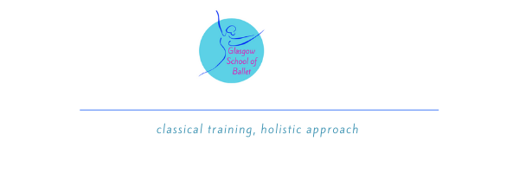
TERMS & CONDITIONS

PLEASE READ THIS CAREFULLY TO FAMILIARISE YOURSELF WITH OUR PROCEDURES AND TO AGREE THAT YOU ARE HAPPY WITH THE WAY WE ARE MOVING FORWARD.

I would like to take this opportunity to say how excited we are to be welcoming you into our school.

POLICY STATEMENT
The aim of Glasgow School of Ballet is to ensure that all pupils experience dance in a fun, friendly, positive, and safe environment. To achieve this, please take note of the following guidelines.

TERM ENROLMENT
When enrolling your child in the school please be aware that you are committing to a full 12week term. NO REFUNDS will be given if you decide to remove your child from the class prior to the term ending. It is important that you are comfortable with this before enrolling your child in the school.

CLASS PROCEDURE
Please read the below details carefully so you are comfortable with our class procedures.

- In general, no parents will have access to the building. Pupil’s will be dropped off at their allocated point where a member of staff will greet them. This will also be the pick-up point. Parents will not be able to stay in the class and the option to enter is, only, to initially settle your child in the building. It is absolutely necessary that you try to prepare your child to come into the class with the teacher as this is our safest option.
- It would be helpful if pupils could wear their ballet uniform to and from class as we have limited changing areas.
- Please send pupils in easy changing shoes (e.g. Wellies or pull on shoes/boots) with their ballet shoes in a small bag to make it easy for teachers and assistants to help.
- Our venue has 2 halls with 2 separate entrances so please familiarise yourself with the entrance relevant to your child’s class.
- All children must be signed in if you are running late there may not be the opportunity to then attend that class.

ENTRANCE
The entrances for children to be dropped is at the side of the building on Deanston Drive. There will be staff there to welcome the children and to say goodbye to them before and after class. Please don’t arrive too early as there is no access to the building before and on collection, please do not be late to collect your child as there is limited time between classes and this holds our teaching staff back from starting their next class.

DISCIPLINE
Pupils are expected to behave in an orderly, civilised, and well-mannered way and to show respect to their teachers, assistants, volunteers, and other pupils when attending Glasgow School of Ballet. Failure to comply with the rules and regulations may result in withdrawal from the school.

BULLYING IS NOT TOLERATED AT GLASGOW SCHOOL OF BALLET.

UNIFORM
It is extremely important that students arrive dressed and ready for class in full School uniform to be able to work correctly and safely in class. All pupils (if hair permits) should have their hair in a ponytail or preferably a bun.

All Uniform can be purchased from our new online store: https://lik.mydancestore.co.uk/
Any queries regarding uniform must be directed to: uniforms@glasgowballet.net

SAFEGUARDING
Glasgow School of Ballet has a duty of care to provide a safe environment and to promote the health and well-being of children under the age of 18 years and adults at risk. Glasgow School of Ballet will take all reasonable steps to ensure that safeguarding and promoting the welfare of children and vulnerable adults is embedded in our contact with them through the training and activities we provide.

POLICIES
Our policies, including our safeguarding policy, can requested at any time, and can be found on our website.

If you are not comfortable with any of the above details, please get in touch so changes can be made before enrolling in the school. Feel free to email, message or contact me to arrange a phone call at a suitable time.

Now let’s get back to doing what we do best… DANCING!!

PRINCIPAL TEACHER

Gemma Lockhart RAD RTS
Managing Director and Principal Teacher
Glasgow School of Ballet

07880580538
gemma@glasgowballet.net

